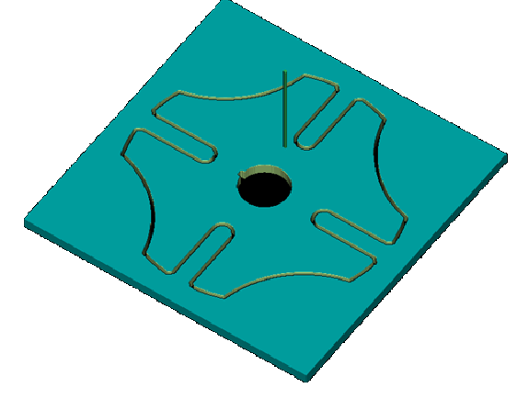

Name: Sign:
USN:
Date:

